High School Lesson Plan Template and Primary Sources: Civil Disobedience, 1960’s and Now
April Adams, Tracy Foster, Wade Hamm, India Meissel, and Joel Rosenzweig
1. | Essential Question/Prompt: | Are you really ready for a protest: Preparing for Civil Disobedience
2. | Lesson Plan | - Bell Ringer: Using the photograph of Clarence Broadnax at Piccadilly Cafeteria Civil Rights Protest  - Student will caption the photograph  - Student will analyze the photograph using the APPARTS method of analysis. (See attachment.)  - Class discusses.  - Break students into small groups: Use the SCLC pamphlet to prompt student discussion about the rules for affecting change using assigned pamphlet sections per group. Report findings.  - After the breakout section is completed, the students will return for either group discussion or Socratic seminar, returning to the Piccadilly photo to discuss how their assessment/understanding of the picture has changed based on the discussions of the SCLC pamphlet.  - Would you be willing to join a protest?  - What are protest-worthy topics now? (Syria, Invisible Children, etc.)  - If you were a trainer for the Civil Rights protests, how would you go about training people? Students create their own pamphlet of instructions for protesting today. Include things such as:  - Rules for social media  - How to handle people who break the rules  - How to handle people who disagree with the group’s decision.
3. | Standards: State & National | National Standards: Era 9, Standard 4a  TEKS: 113.32-9a,b,f; 113.29b,e.f
Resource Set
Photograph of Clarence Broadnax at Piccadilly Cafeteria Civil Rights Protest | Southern Christian Leadership Conference Handbook for Freedom Army Recruits | Eyes on the Prize: 02: Fighting Back, 1957-1962 | John F. Kennedy Address on Civil Rights | APPARTS Definitions | (Resource Title Here)
Photo: June, 5, 1964 | Document: 1964 | Oral Histories | Video | Handout | (Context)
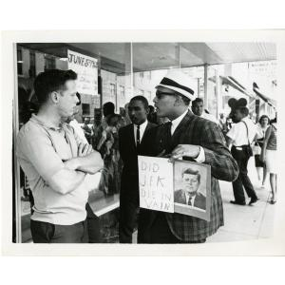 | 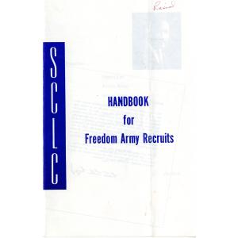 |  | 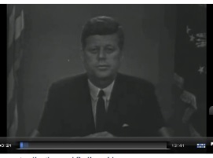
http://eMuseum.jfk.org/view/objects/asitem/items@:26553 | http://eMuseum.jfk.org/view/objects/asitem/items@:28685 | http://www.youtube.com/watch?v=2a32Uc1oP7s | http://www.jfklibrary.org/Asset-Viewer/Archives/TNC-262-EX.aspx | http://chnm.gmu.edu/cyh/archive/files/apparts_b60cd02284.pdf | (Resource Link Here)

