High School Lesson Plan Template and Primary Sources:
Jim Crow vs. Juan Crow Court Cases
April Adams, Tracy Foster, Wade Hamm, India Meissel, and Joel Rosenzweig
1. | Essential Question/Prompt: | Compare and contrast the Jim Crow and “Juan Crow” experiences regarding the handling of the integration of education by the Judicial and Executive branches of the US Government.
2. | Lesson Plan | This will be an online based research project that can be conducted either during Hispanic Heritage Month or within a Civil Rights unit. The instructor will decide whether to conduct this research in a computer lab, in the classroom, as a BYOT/BYOD activity, as an at home assignment or a combination or any of the above.  - Introductory lecture regarding Brown v. Board and comparing it to Hernandez v. Texas. (See attached case summaries.), including excerpts from Oral Histories from The Sixth Floor Museum’s Collection.  - Review specific web sites that can be used for this activity. (See list in PDF.)  - Using the document analysis worksheet from (from the National Archives) or the IRAC method for briefing cases (see PDF), students will complete the analysis for four court cases (2 Jim Crow and 2 Juan Crow) from the list below:  Jim Crow Juan Crow  Morgan v. Virginia Mendez v. Westminster  Sweatt v. Painter Hernandez v. Driscoll CISD  Jackson v. Rawdon Delgado v. Bastrop ISD  - Based upon the rulings of the court cases selected, the student will create a Venn diagram that demonstrates knowledge of the similarities and differences between the Jim Crow and Juan Crow civil rights experience and present to the class.
3. | Standards: State & National | National Standards: Era 9, Standard 4a  TEKS: 113.32.9a,b,c,f,h,i  113.32.23b  113.29a,b,c,e,f,g

Resource Set
National Archives | Bob Ray Sanders | Medrano Brothers | Viva Kennedy Button | White House Press Release | White House Telegram Transcript
Document Analysis Worksheet | Oral History Excerpt | Oral History Excerpt | Part of the 1960 Presidential campaign | September 30, 1962 | September 30, 1962.
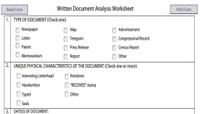 | 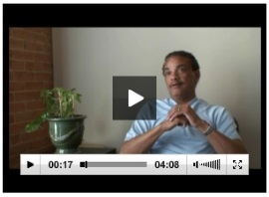 | 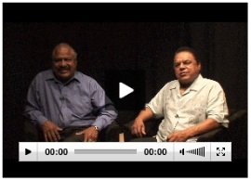 | 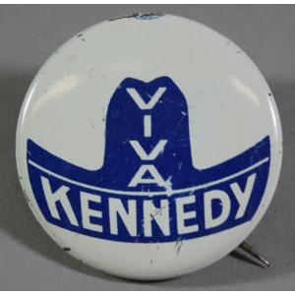 | 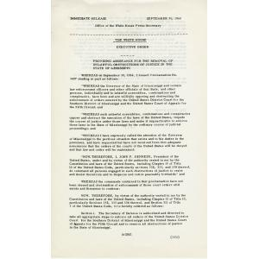
www.archives.gov/eduction/lessons/worksheet/written_document_analysis_worksheet.pdf | http://eMuseum.jfk.org/view/objects/asitem/items@:26363 | http://eMuseum.jfk.org/view/objects/asitem/items@:33030 | http://eMuseum.jfk.org/view/objects/asitem/items@:35152 | http://eMuseum.jfk.org/view/objects/asitem/items@:31375 | http://eMuseum.jfk.org/view/objects/asitem/items@:31376

Resource Set adapted from Teaching with Primary Sources, Library of Congress
Other Document Needed:
Court Cases PDF

