Middle or High School Lesson Plan Template and Primary Sources: Oral Histories and the Legacy of President John F. Kennedy
April Adams, Tracy Foster, Wade Hamm, India Meissel, and Joel Rosenzweig
1. | Essential Question/Prompt: | What is the legacy of President Kennedy 50 years after his assassination?
2. | Lesson Plan | - The teacher should give students an introduction regarding how to conduct an oral history interview and show students a clip of previously conducted (and recorded) interviews. (See resource set for examples.)  - Find a family member or family friend born prior to 1956. Establish a rapport with the person being interviewed. During the minimum 30 minute interview, the following questions should be asked:  - Where were you when John F. Kennedy was shot?  - What was your initial reaction?  - What do you recall/remember from the subsequent days?  - What he an effective president/leader? Why/why not?  - What do you feel is his legacy to the American people?  - What impact did he have on the Civil Rights Movement for African-Americans and Latinos?  - Students should be prepared to ask appropriate follow up and additional questions to make their interview as complete and interesting as possible.  - Turn the camera on yourself and ask the following questions:  - How did your oral history interview make you feel about history and about President Kennedy  - What does President Kennedy’s life and legacy mean to you, 50 years after his assassination?
3. | Standards: State & National | National Standard Era 9  TEKS: 113.32-9a,b,f; 113.32-29b,e,f
Resource Set
Oral History listings at The Sixth Floor Museum | Oral History steps | Oral History Association | Oral History Web resources | (Resource Title Here) | (Resource Title Here)
Video examples | Website | Website | Website | (Context) | (Context)
 | 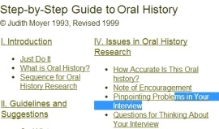 |  | 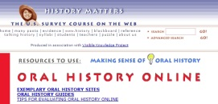
http://emuseum.jfk.org/view/objects/asimages/84/0/title-asc?t:state:flow=99ccbea7-90d9-4222-949f-2cf24c49e959 | http://dohistory.org/on_your_own/toolkit/oralHistory.html | http://www.oralhistory.org/ | http://historymatters.gmu.edu/mse/oral/online.html | (Resource Link Here) | (Resource Link Here)

Resource Set adapted from Teaching with Primary Sources, Library of Congress

