Middle School Lesson Plan and Primary Sources: Viva Kennedy Movement
Group Plan by Keith Johnson, Terry Perry, Doris Boat, Malissa Allen, Megan Capshaw, Lori Simone-Acosta, Judith Anderson-Bruess

1. | Essential Question/Prompt: | How did Kennedy & Hispanic community influence each other?
2. | Lesson Plan | How did these people, organizations, and events impact Civil Rights for Latinos in Texas?  Hector Garcia Henry Gonzalez Albert Pena Francisco Medrano George Sanchez  (other Latino Civil Rights Leaders can be added)  American GI Forum LULUAC PASSO  Houston –Rice Ballroom speech Nov.21,’63 Telegram-Nov 10’ 60  - Assign an individuals, event, or organization to a student to research from at least 3 sources how the person etc. impacted Texas Civil Rights.  - Report to class on assigned person, etc.; class will take notes that can be used to for assessment.
3. | Standards: State & National | TEKS: 7.1A, 7.7D; 6.1B; 11th grade-2A, 9B, 9C  National Standards: ERA 7 #3, ERA 9 #4, ERA 10 #2
4. | Rubric for Assessment | Matching-attached
Resource Set
Viva Kennedy | Focusing on Latino History | JFK and LULAC | PASSO | Latino Leader | Latino Leader
A Campaign Button | The American GI Forum & Presidential Politics | JFK MEETS WITH LULAC | Political Association of Spanish Speaking Orgs. | Henry B. Gonzalez | Hector P Garcia
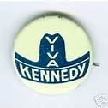 | 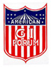 | 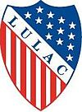 | 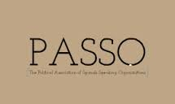 | 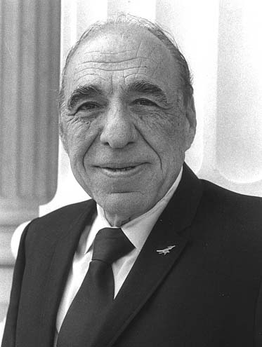 | 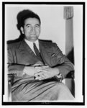
http://eMuseum.jfk.org/view/objects/asitem/items@:35152 | http://kennethburt.com/blog/?p=875 | http://latinopia.com/latino-history/latinopia-moment-in-time-jfk-meets-with-lulac | http://www.tshaonline.org/handbook/online/articles/vep01 | http://www.loc.gov/rr/hispanic/congress/gonzalez.jpg | http://www.loc.gov/pictures/item/2007684154/
Latino Leader | Latino Leader | Latino Leader | Telegram | You Tube Clip
Albert A. Pena, Jr | Francisco “Pancho” Medrano | George I. Sanchez | Kennedy to Viva Kennedy | President Kennedy in Houston on Nov. 21, 1963
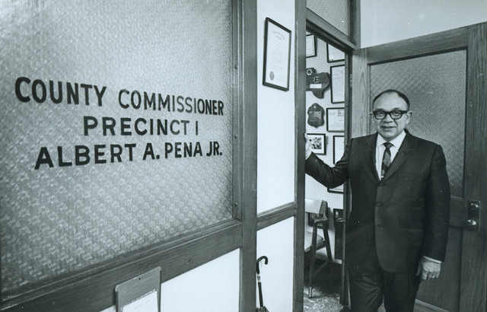 | 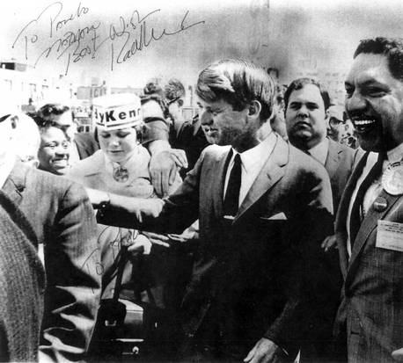 | 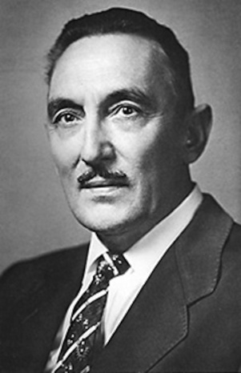 | 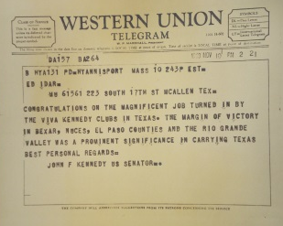 | 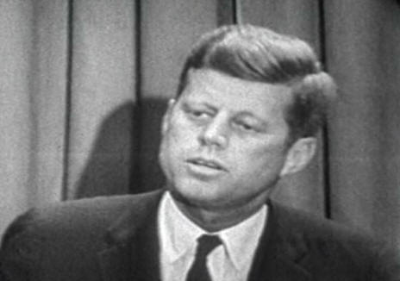
Gabriel Quintero Velasquez’s Flickr photo stream, original source unknown | http://dallasne.ws/1foH3fa | http://www.utexas.edu/cola/files/1163535 | Ed Idar Jr. Papers, Benson Latin American Collection, UT-Austin | http://www.youtube.com/watch?v=YZUTGqLQtF4
Resource Set adapted from Teaching with Primary Sources, Library of Congress
Kennedy and Hispanic Community Assessment

Name ______________________________ Per. ____
Last, First
Match the terms from Column A to those from Column I. Be sure to put the correct letter from Column I prior to the number in Column A.

Column A Column I

_____ 1. Hector P. Garcia A. Mexican-American leaders in Dallas
_____ 2. Henry Gonzalez B. “Statement of Principles”
_____ 3. Albert Pena C. Elected to Texas Senate
_____ 4. Medrano Brothers D. LULAC listeners
_____ 5. J.O. “Pepper” Garcia E. United Latin’s in 1929
_____ 6. George Sanchez F. Hernandez v Texas 1954
_____ 7. American GI Forum G. Spanish Speaking, Political
_____ 8. LULUAC H. Dallas PASO leader
_____ 9. PASO I. County Commissioner, attorney, LULAC
_____10. Houston –speech Nov.21,’63 J. Military Veterans

BONUS: Name the sender and receiver of the telegram sent Nov 10’ 60.
Sender:

Receiver:

Kennedy and Hispanic Community Assessment

Name __________KEY________________ Per. ____
Last, First
Match the terms from Column A to those from Column I. Be sure to put the correct letter from Column I prior to the number in Column A.

Column A Column I

___F__ 1. Hector P. Garcia A. Mexican-American leaders in Dallas
__C___ 2. Henry Gonzalez B. “Statement of Principles”
_I____ 3. Albert Pena C. Elected to Texas Senate
__A__ 4. Medrano Brothers D. LULAC listeners
_H___ 5. J.O. “Pepper” Garcia E. United Latin’s in 1929
_B___ 6. George Sanchez F. Hernandez v Texas 1954
__J__ 7. American GI Forum G. Spanish Speaking, Political
___E_ 8. LULUAC H. Dallas PASO leader
__G__ 9. PASO I. County Commissioner, attorney, LULAC
_D___10. Houston –speech Nov.21,’63 J. Military Veterans

BONUS: Name the sender and receiver of the telegram sent Nov 10’ 60.
Sender: Senator John F. Kennedy
Receiver: Albert Pena

