By India Meissel
High School Lesson Plan and Primary Sources: Memorialization
1. | Essential Question/Prompt: | How do we choose to remember and memorialize people and events in history?
2. | Lesson Plan | 1) Lecture/discuss with students different types of monuments and memorials and show examples of each:  - Spontaneous memorials (items immediately placed at the site of a tragedy or a memorial constructed without a thought out plan)  - Traditional memorials - (Those celebrating or honoring a person or event: memorial planned, thought out, and funds raised)  - Monuments in Conflict - (different perceptions/memories trying to control the view of history)  - "Personal Memorials" - (T-shirts/buttons honoring lost friends or loved ones)  - Other types - (i.e. oral history, school buildings, street names)  2) Why is it important to keep history (people/places/events) in our memory and memorialize them? Should we remember and memorialize?  3) After the discussion students should then design, build, and interpret a memorial of a topic of their choosing. Questions to think about when planning include: (and the answers should be written down or discussed by the student upon presenting the final product)  - Who is the audience for this monument/memorial?  - What do you want them to think about/understand when viewing your monument/memorial?  - What is your point of view with this monument/memorial? (What is its message?)
3. | Standards: State & National | National Standards: Eras 1-10 are relevant depending on student choice of era for memorial  TEKS: 113.29a-g
4. | Rubric for Assessment | Teacher created rubric for the monument/memorial design, construction and interpretation
Resource Set
Spontaneous Memorials | Traditional Memorials | Traditional and Controversial/Conflict Memorials | Memorials in Conflict | "Personal" Memorials | "Personal Memorial"
photographs | pamphlet | website | website | website | website
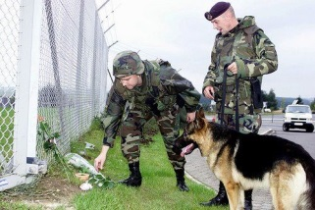 | 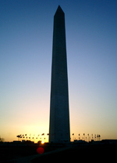 |  | 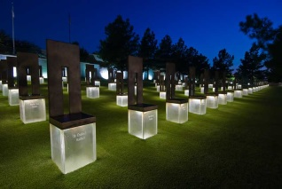 | 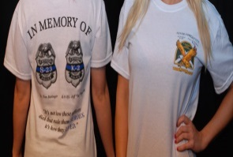 | 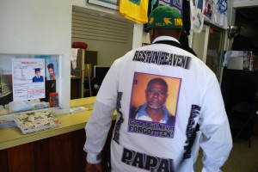
http://spontaneousmemorials.tumblr.com/ | http://www.nps.gov/wamo/index.htm | http://www.911memorial.org/?gclid=CLiK1Mi13LgCFWQV7AodZTgAuQ | http://www.oklahomacitynationalmemorial.org/ | http://www.970wfla.com/common/stpetepd.html | http://oaklandnorth.net/2009/09/04/keeper-of-memoriescampbell-search-organizer-known-for-memorializing-missing-youth/
"Other" Memorials | "Other Memorials" | Memorials in Conflict
Oral History Clip | Oral History Clip | Website
 | 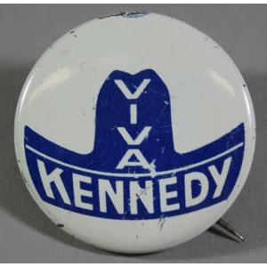 | 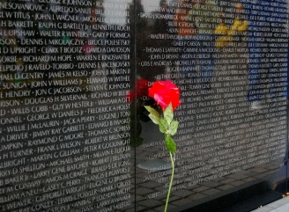
http://eMuseum.jfk.org/view/objects/asitem/items@:26458 | http://eMuseum.jfk.org/view/objects/asitem/items@:35152 | http://www.nps.gov/vive/index.htm

Resource Set adapted from Teaching with Primary Sources, Library of Congress

