Elementary Lesson Plan and Primary Sources: by Aundrea Wright-Young and Adriana Marroquin
1. | Essential Question/Prompt: | Viva Kennedy! How did the Civil Rights movement affect life for Mexican-Americans in Texas?
2. | Lesson Plan | Read or watch the following excerpt from President John F. Kennedy’s Address to the American People on Civil Rights:  “The heart of the question is whether all Americans are to be afforded equal rights and equal opportunities, whether we are going to treat our fellow Americans as we want to be treated. If an American, because his skin is dark, cannot eat lunch in a restaurant open to the public, if he cannot send his children to the best public school available, if he cannot vote for the public officials who represent him, if, in short, he cannot enjoy the full and free life which all of us want, then who among us would be content to have the color of his skin changed and stand in his place? Who among us would then be content with the counsels of patience and delay?” June 11, 1963  Role-Play Activity:  Let’s go back in time to 1963. After watching the Presidential Address on Civil Rights, you visit the store with your mother and you see the sign. Display the following image:  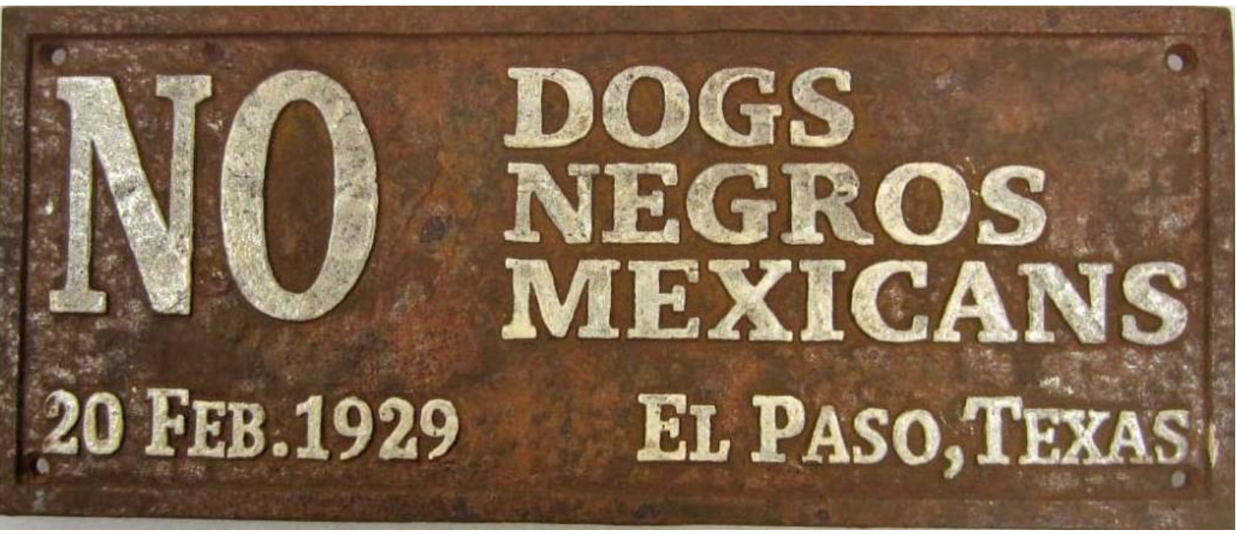  How would you react? What are your thoughts? How do you feel?  The students are then divided into small groups. Each group will assign a recorder and speaker who will address the entire class and share their thoughts concerning the image.  While the students discuss and react to the image, the teacher observes and facilitates the learning. The speaker and recorder present each group’s findings to the class.  Complete a Venn Diagram using a SMARTBoard, bulletin or dry erase board. Compare and contrast the words within President Kennedy’s speech and your treatment in the store.  JFK Address  Read, Jack’s Path Of Courage: The Life of John F. Kennedy by Doreen Rappaport.  Store Treatment  Extension Activities: Add Dr. King’s “I have a dream…” speech, and contrast with local images.
3. | Standards: State & National | Common Core Standards  Speaking and Listening Grade 5  Comprehension and Collaboration  1. Engage effectively in a range of collaborative discussions (one-on-one, in groups, and teacher led) with diverse partners on grade 5 topics and texts, building on others’ ideas and expressing their own clearly.  Presentation of Knowledge and Ideas  5. Include multimedia components (e.g., graphics, sound) and visual displays in presentations when appropriate to enhance the development of main ideas or themes.  Texas Essential Knowledge and Skills  5.5b The student understands the expansion of American political and economic power both domestically and abroad as a result of international decisions and conflicts from the Cold War to the present.  5.19c The student understands the actions taken by the national government and people from racial, ethnic, and religious groups to explain economic opportunities and political rights in American society  5.24a,b,d,e The student applies critical thinking skills to organize and use information acquired from a variety of sources including electronic technology.
4. | Rubric for Assessment
Resource Set
Juan Crow | Dallas Segregation Signs | President Kennedy Address on Civil Rights | Viva Kennedy Pin | (Resource Title Here) | (Resource Title Here)
Mexican-Americans in Texas | Lonestar Restaurant Association, Dallas, TX | President Kennedy speaks about change. | Hispanic-American support for JFK in 1960 | (Context) | (Context)
 | 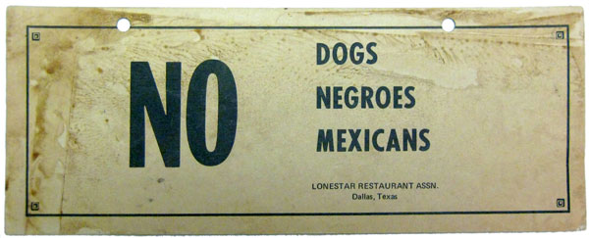 | 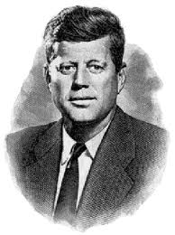 | 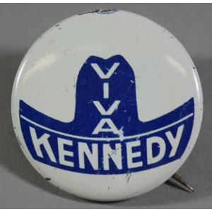
http://menudoreport.com/TMR-racism.html | http://tinyurl.com/m68ydj3 | http://tinyurl.com/lwb7ule | http://eMuseum.jfk.org/view/objects/asitem/items@:35152 | (Resource Link Here) | (Resource Link Here)
Resource Set adapted from Teaching with Primary Sources, Library of Congress

