Middle School Lesson Plan Template and Primary Sources: Bullying & Injustice
1. | Essential Question/Prompt: | How is social injustice related to bullying?  “If you are neutral in a situation of injustice you have chosen the side of the oppressor.” Desmond Tutu
2. | Lesson Plan | - What is bullying? Have students discuss and give examples.  - Definition: Bullying is unwanted, aggressive behavior among school aged children that involves a real or perceived power imbalance. The behavior is repeated, or has the potential to be repeated, over time. Both kids who are bullied and who bully others may have serious, lasting problems. In order to be considered bullying, the behavior must be aggressive and include:  - An Imbalance of Power: Kids who bully use their power—such as physical strength, access to embarrassing information, or popularity—to control or harm others. Power imbalances can change over time and in different situations, even if they involve the same people.  - Repetition: Bullying behaviors happen more than once or have the potential to happen more than once.  - Bullying includes actions such as making threats, spreading rumors, attacking someone physically or verbally, and excluding someone from a group on purpose.  - Prompt a conversation about injustice by asking a series of questions:  - Who are victims of injustice? Who are perpetrators?  - What happens when a whole society has laws and attitudes that are unjust? (Leads to social injustice. Discuss other examples of social injustice in the US & in the Dallas area; for example, school integration and – Santos Rodriguez)  - Is there such a thing as political bullying?  - Is there anyone too powerful to be bullied? (Show Wanted for Treason flyer and discuss.)  - What is the role of the government in contesting political bullying?  - What is the citizen’s role in contesting social injustice?  - Show the “28 Days at the Piccadilly” video clip and photograph of Clarence Broadnax outside the Piccadilly Cafeteria from JFK.org  - What did you hear in the video that was unfair? What examples of bullying did you see in the photo?  - Optional Extension Activities:  - Show the video “Don’t be a bystander” from www.stopbullying.gov & discuss.  - Oral history project on bullying to be archived in the counselor’s office at school and used for anti-bullying presentations at the school. Student’s focus should be:  - What does bullying look like (to promote awareness of various forms of hurt),  - Solutions/ options to avoid cope with bullying,  - Bystander to bullying problems.  - Walk student through how conduct an oral history interview. Utilize websites that explain how to conduct an oral history. Students should generate a topical list of questions for the interview. Students should have their interviewee sign a release form designed by the counselor’s office.
3. | Standards: State & National | National Standards: Era7#3, Era9#4, Era10#2
4. | Rubric for Assessment | For Oral History Interview: http://www.edmondschools.net/Portals/0/docs/InterviewRubric.pdf
Resource Set
Wanted for Treason | 28 Days at the Piccadilly | Stop Bullying.gov  “Be more than a bystander” | Santos Rodriguez | Little Rock integration | Clarence Broadnax at the Piccadilly Cafeteria
Flyer | Video | Website | Photo and Article | Photograph | Photograph
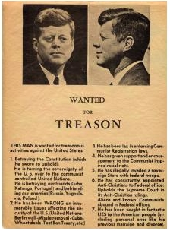 | 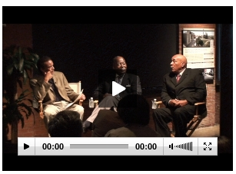 | 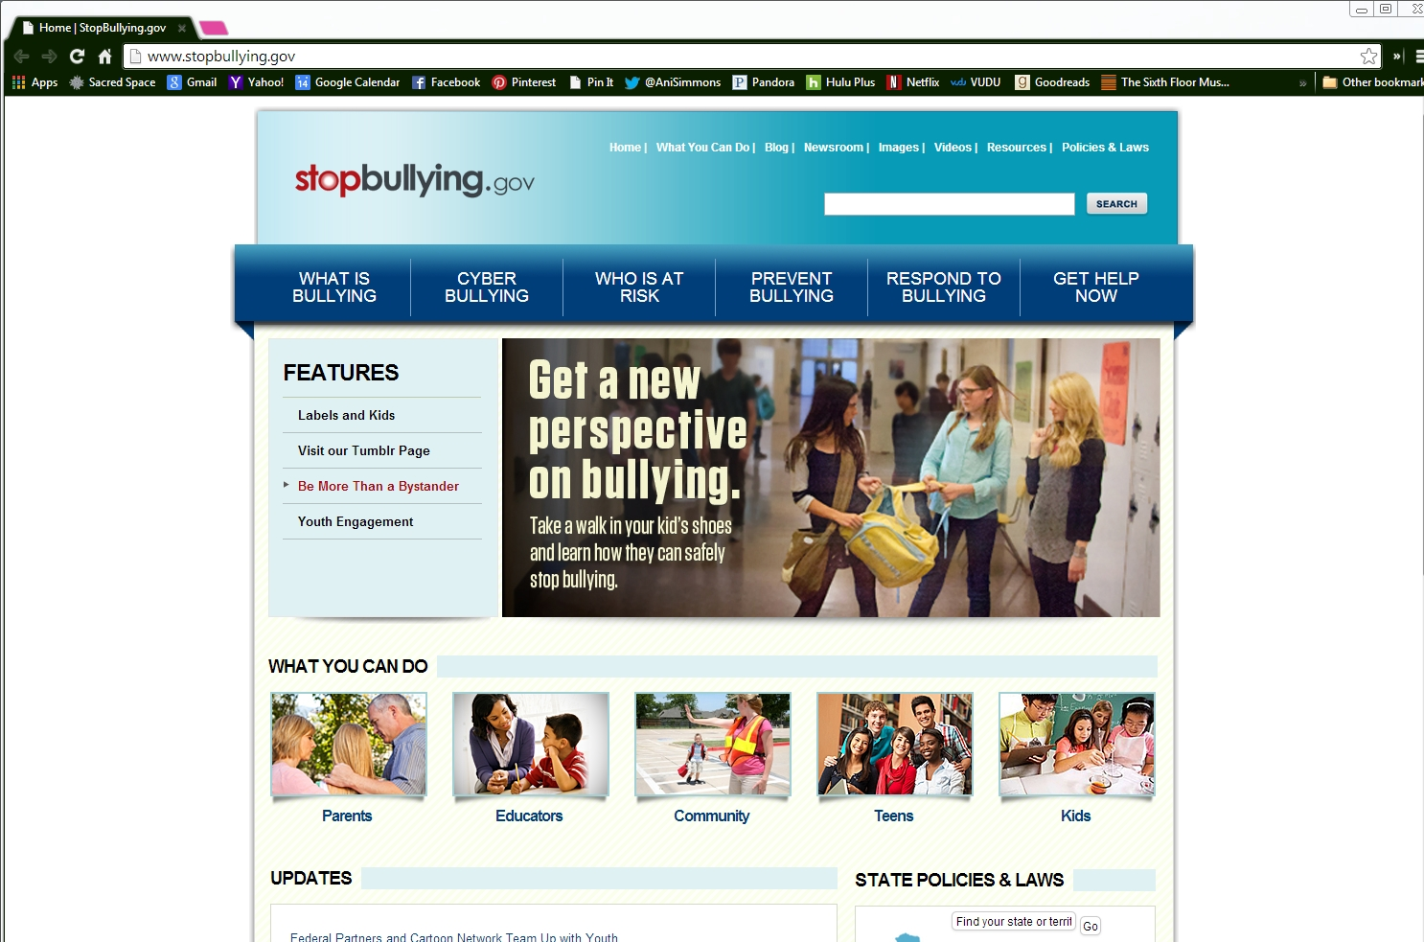 | 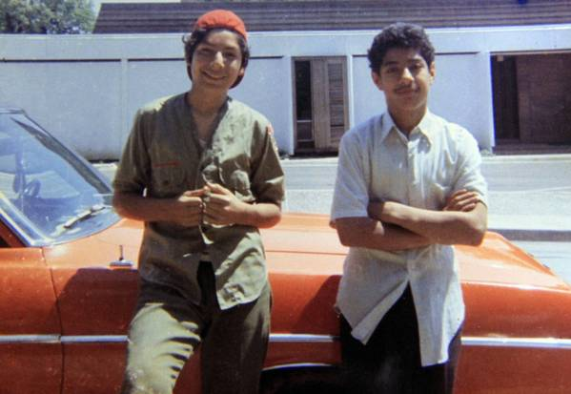 | 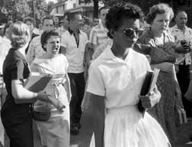 | 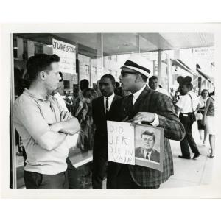
http://eMuseum.jfk.org/view/objects/asitem/items@:19684 | http://eMuseum.jfk.org/view/objects/asitem/items@:26458 | www.stopbullying.gov  https://www.youtube.com/watch?feature=player_embedded&v=5JZ5yk5kkFA | http://www.dallasnews.com/opinion/editorials/20130722-editorial-the-unrealized-dream-of-santos-rodriguez.ece | http://www.nps.gov/nr/travel/civilrights/ak1.htm | (http://eMuseum.jfk.org/view/objects/asitem/items@:26553 )

Resource Set adapted from Teaching with Primary Sources, Library of Congress

