Group Plan by Keith Johnson, Terry Cherry, Doris Boat, Malissa Allen, Megan Capshaw, Lori Simone-Acosta, Judith Anderson-Bruess
Middle School Lesson Plan and Primary Sources: School Names – Who decides?
1. | Essential Question/Prompt: | Based on your knowledge of Civil Rights, how do local school names reflect positive changes brought about by the Civil Rights Movement?
2. | Lesson Plan | Warm-up: “Students, your school district wants to name a school for you or your family. Why would they do that?” Think/Pair/Share and report orally to the class.  Follow Up Discussion Question: There are many schools named after President John F. Kennedy, the 35th President of the United States. Why do you think that is? (Show visual #1)  Readings: Given 5 biographies of people for whom schools are named in Dallas, students, again in pairs, will read the attached biographies and look for common traits: Sam Tasby, Cesar Chavez, Barbara Jordan, and Rosa Parks. The pair will write down 6 adjectives describing the five people (Six Word Story).  Research: On slips of paper, the teacher will write the names of the following Civil Rights leaders and randomly assign one to each pair. Using the internet and classroom resources, students will research Martin Luther King, Booker T. Washington, John F. Kennedy, Juanita Craft, Thurgood Marshall, Henry B. Gonzalez, Lyndon B. Johnson, Dr. Hector Garcia, Albert Pena, and Emma Tenayuca. Students will write a biography the approximate length of the ones they have been given. They will present these to the class.  Group Project: The students will then choose the person they think is most worthy of having a school named for them. They will form a group with other like-minded students, no larger than 6 students. The group project is to create a campaign to get their choice to have a school named for them. The student group needs to use at least 3 media to create their campaign. To help them focus, explain to them they will need to present their campaign to the Board of Education, the City Council, religious institutions and leaders in the community.
3. | Standards: State and National | TEKS: 7.7D Students will demonstrate understanding of important eras in Texas (Civil Rights Era)  TEKS: 7.16 Students understands rights and responsibility of Texas citizens  National Standards: Era 7 #3, Era 9 #4, Era 10 #2
4. | Rubric for Assessment | The student groups will present their campaign to the class. The assessment rubric will consist of:  1. 34 points: Research? weak adequate strong  2. 33 points: Persuasive? no somewhat very  3. 33 points: Effort and Participation? poor adequate exemplary

Resource Set
President Kennedy shaking hands on 11/22/63 | Cesar Chavez | Barbara Jordan | Sam Tasby | Rosa Parks | Maya Angelou
Shook hands with everyone | Fought for Hispanic workers rights | Lawyer, Senator, Civil Rights activist | DISD Desegregation leader | Civil Rights activist | Civil Rights activist
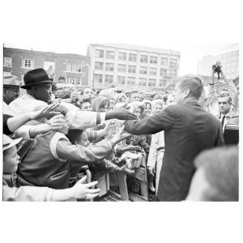 | 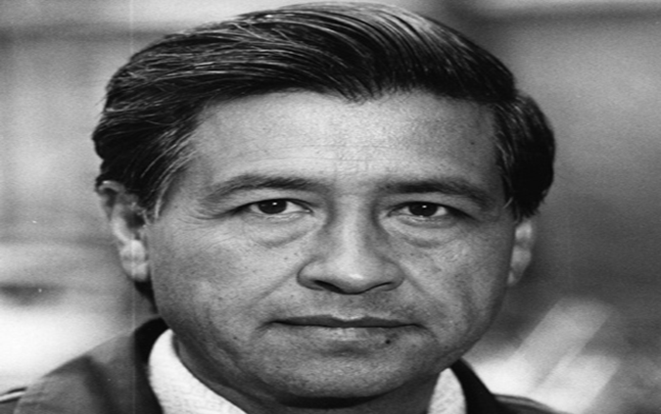 | 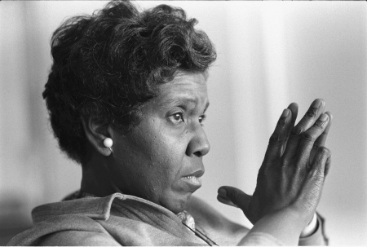 | 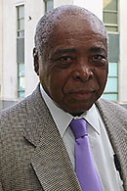 | 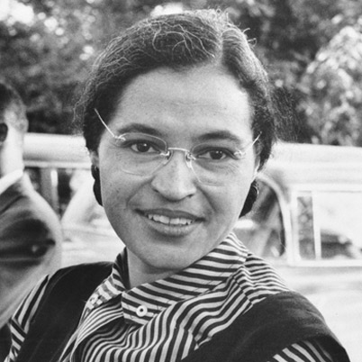 | 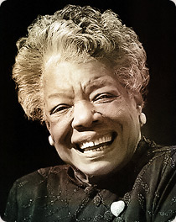
http://eMuseum.jfk.org/view/objects/asitem/items@:3176 | http://www.biography.com/people/cesar-chavez-9245781 | http://www.tshaonline.org/handbook/online/articles/fjoas | http://dallasne.ws/14eJBrr | http://www.history.com/topics/rosa-parks | http://mayaangelou.com/bio

Resource Set adapted from Teaching with Primary Sources, Library of Congress

